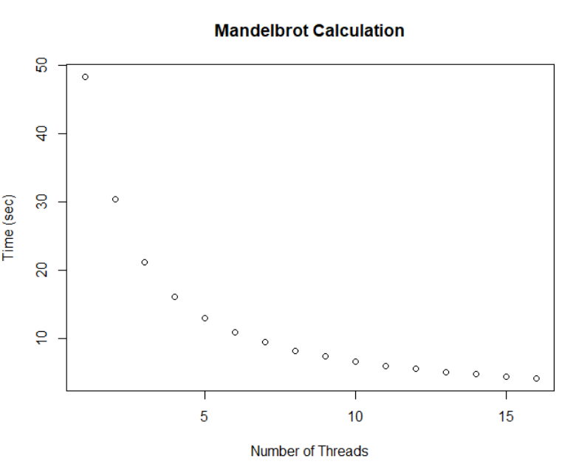

As you can see from the graph above, as you increase the number of threads the amounts of time it takes to do the calculations decreases.